Description and user manual
for electronic timer for control line models (V7.2)

Description and technical parameters:
Electronic timer is identified for control of flying time of control line models powered by electro motors at same, user adjustable power. He give a possibility to delay the motor start about 20 or 40 seconds, his ramp-up to adjusted power between 30% and 100% in 5 seconds, run of motor during user adjusted time and after this ramp-down in 5 second or 5 second of full power and jump to 0%. The timer expect control of motor by standard ESC with BEC circuit with which is the timer powered and with which are sent to the ESC driving signals.
Basis of timer is programmable microprocessor PIC12F629, which is fixed in socket on the PCB together with filtering condenser, high illuminative LED with adequate resistor, 3 pins connector for connection of ESC and 3 pins connector through which is possible to change time to start, flying time, flying power and kind of flying end. Fixation of timer is designed by 2 wood screws ∅ 2mm. But with view to the weight is fixation possible by self gluing tape or by another way depend possibilities.

Power voltage: 4,8 – 5,5 V (warning from ESC, which are set 6V as default)
Dimension and weight 22x18x14mm, 3g
Selectable time to start 20 or 40 seconds, default 40s
Adjustable flying time 10 - 1200 sec, default 200 seconds (3:20 minutes)
Adjustable motor power (for whole flight) 30 -100%, default 100%
The way of flight end ramp down in 5 seconds or 5seconds full power (100%) and then switch off
Large of filtering condenser recommended min. 100M/10V, with very good ESC is not necessary
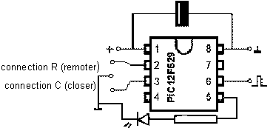
Circuit schema:
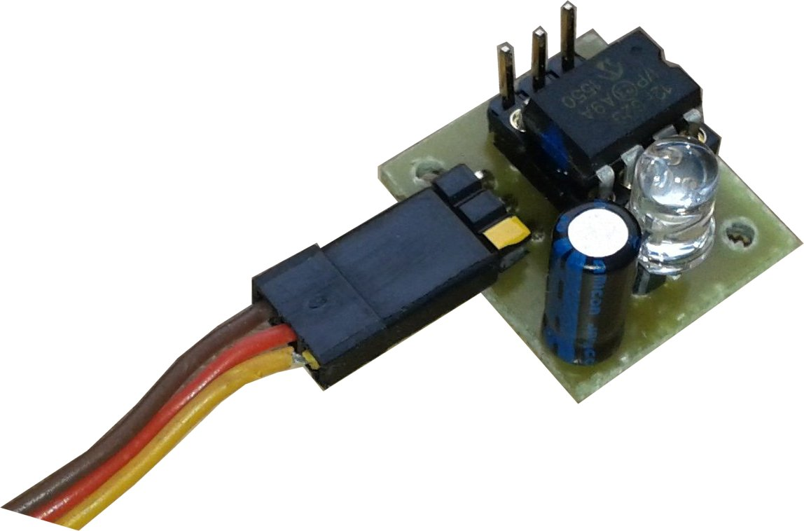

white Mark

Security warning:
The equipment control electromotor with propeller. In case of incorrect manipulation can motor unexpected run with potential damage of things or injury. Until the batteries are connected, every time you must expect, that motor can run. From same reason don´t leave near propeller cables, wires and other small things, which can be by propeller winded around or sucked and fling away. The equipment connects the motor for continuing power up 100%. ESC and motor must be selected with view of continuing full power. Information about tested sets of motor, ESC and batteries you can ask on mail in Contacts chapter. Producer and seller are not responsible for damages, which have reason out of here described manipulations.

Guideline for connection:
The timer has to be fixed on or in model to be LED can shine to the flying circle centre (to the pilot). LED is installed in socket, therefore is possible to locate LED everywhere and connect it with help of extension lead. To have timer pins accessible is recommended.
To the timer to horizontal 3pins connector to connect BEC cable from ESC. Warning for right polarity.
central (red) wire is plus,
hell (white, yellow, beige) side wire is control signal, on 3pins marked by white point.
dark (black, brown) side wire is minus,

In the vertical 3pins connector has to be for standard traffic no jumper.
Two pins of vertical 3pins connector, which are closer to the horizontal connector (ESC) are next marked as C.
Two pins of vertical 3pins connector, which are remoter to the horizontal connector (ESC) are next marked as R.

The connection of rest of power system (motor, ESC, batteries) is standard, ESC and motor can be brush or brushless. Batteries can be any kind (Lixx, Nixx,..) too. Recommended set ups of motors, ESCs and batteries depend on kind and large of CL model you can ask or validate on mail in Contact chapter.

Overview manual for timer adjusting.
Standard flight is through middle vertical down.

Motor, ESC and timer are connected, battery is not connected

jumper on R without jumper jumper on C
Selectable delayed start normal start flying time adjusting

connection of battery connection of battery connection of battery

8s communication sequence 8s communication sequence 8s communication sequence
timer-ESC, LED shine 2s timer-ESC, LED shine 2s timer-ESC, LED shine 2s

short turn of motor, LED blink short turn of motor, LED blink
unlimited waiting for unplug start of stopwatch
of jumper from R, (motor don´t run, LED flash in 1sec interval)
LED blink with longer 4th pause after expiration of requested flying time
unplug jumper from C,
After unplug of jumper from R, New flying time is by this saved.
6s activation, LED don´t shine minimal flying time is 10sec !!!

short turn of motor, LED blink

waiting before start
connection of R (screwdriver, knife, wire,…) (20s or 40s) connection of C (screwdriver, knife, wire,…)
set up of start delay to 20sec LED regularly blink set up of start delay to 40sec
LED during connection shine quick for 20s (3x per 1 sec) LED during connection shine
or slower for 40s (1,5x per 1 sec)
3s before start LED shine constantly

start of motor
5s ramp up from 0% to adjusted power, LED don´t shine

Flight
connection of R (screwdriver, knife, wire,…) motor run with adjusted connection of C (screwdriver, knife, wire,…)
decreasing of power till 30% power (default 100%) increasing of power till 100%
LED don´t shine, rpm are changed during adjusted time LED don´t shine, rpm are changed
(default 200s),
LED don´t shine

10s before flight end (around 2 laps before) switch LED on

LED switch off and end flight sequence is running
(5s ramp down to 0% or 5s 100% and switch to 0%)

2 minutes waiting
connection of R (screwdriver, knife, wire,…) for unplug connection of C (screwdriver, knife, wire,…)
end flight by ramp down of battery end flight by 5s 100% and switch
to 0% (default) LED blink regularly to 0% (for F2B)
LED during connection shine long LED during connection shine
(1x per 2s)

Unlimited waiting for unplug of battery
LED long double blink (1x per 4s)

Unplug of battery

Contact:
jaromir.hoblik@tiscali.cz
We wish you lot of wins and satisfaction at flying with our electronic timer.

